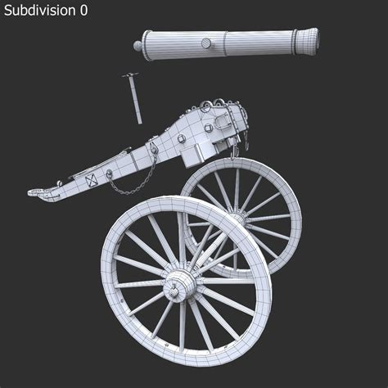
19.09 in circumference-(57 in) Wheels
Barrel 60 in long - 3.6 in diameter
Overall length 10Ft

